1. Create all auxiliary files (WBS, OBS, Rates, Resources)
2. Develop the baseline – create a sandbox to stage development of baseline
3. When the baseline is final, create the new project in Cobra by copying another project. In Cobra, open the project you are copying from. Click File>Save As. **Do not copy the data**.

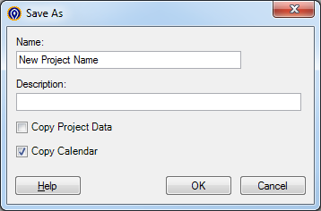

1. Update the auxiliary files linked to the new project if necessary. In Cobra click Project>Project Information. Select the Fields tab. Click the ellipsis for Code File for Control Account Field 1 which should say WBS in the prompt. Navigate to and select the WBS file. Click the ellipsis for Code File for Control Account Field 2 which should say OBS in the prompt. Navigate to and select the OBS file.

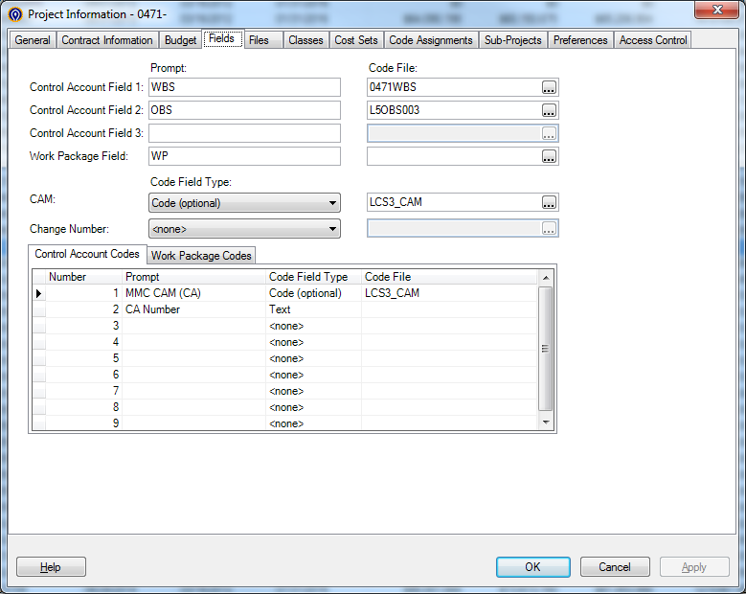

Select the Files tab. Enter the Rate file and Resource file in the appropriate section.

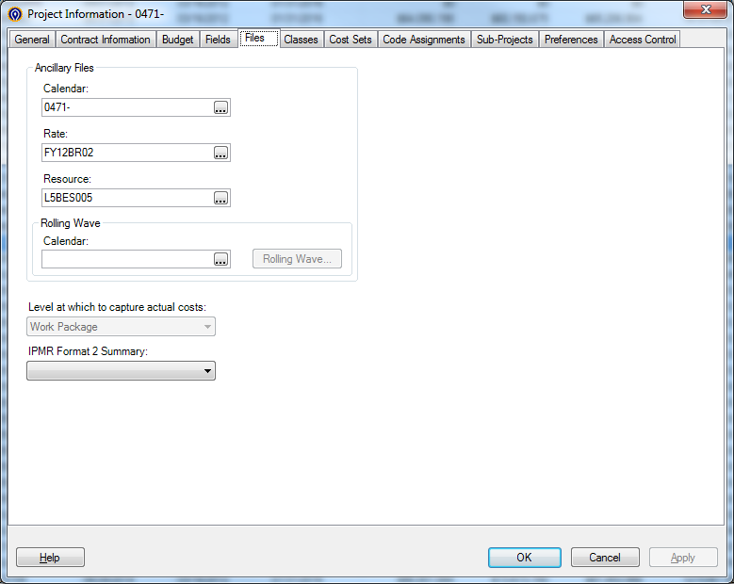

1. Update the calendar. In Cobra, click Calendars on the Navigation Pane. Open the calendar for your project. Select Calendar Set 18. Move the PREVIOUS and TODATE and the * to set the TODATE value to the period one month earlier than the first reporting period. For example, if August is the first reporting period, PREVIOUS should be set to June and TODATE should be set to July. When saving, say “yes” to update calendar set 19.

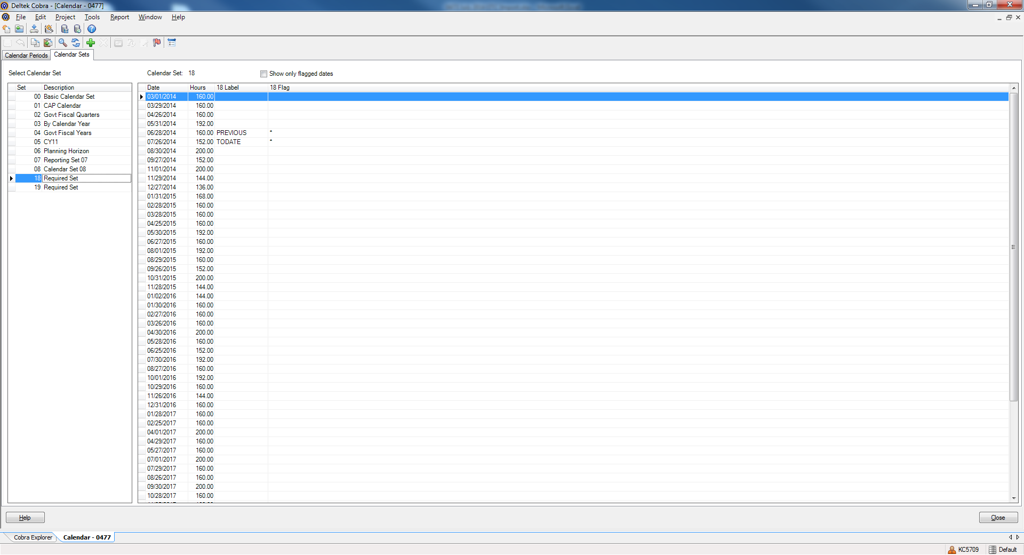

1. Synchronize the project date. In Cobra click Project>Project Information. Select the General tab. Click the Synchronize button to set the project status date to the updated TODATE in the calendar.

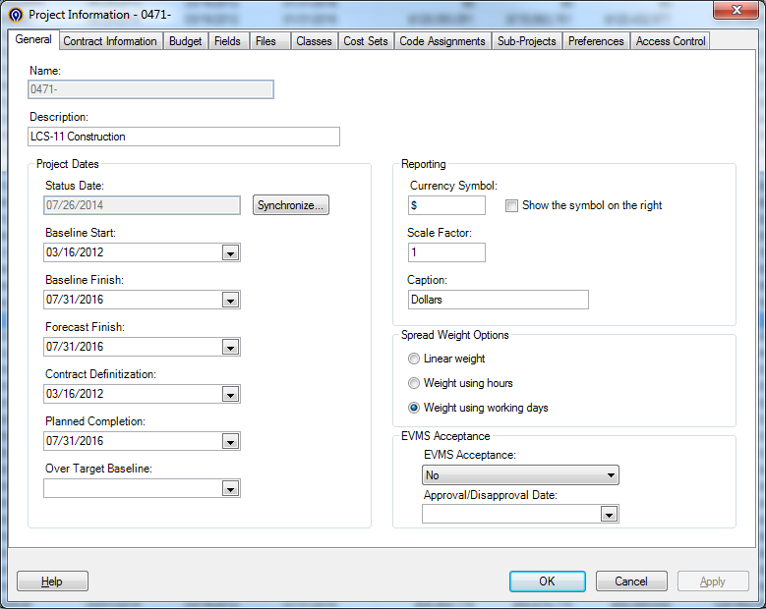

1. Turn the log on. In Cobra click Project>Project Audit. Select the radio button to Turn Log On; DO NOT check the box to Log time phased changes. Click Next.

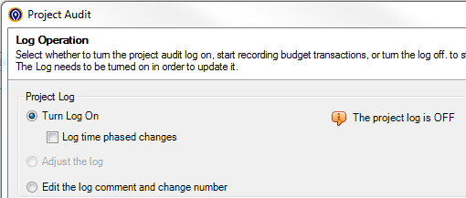

1. Select the radio button to set the Log Level. Click Next.

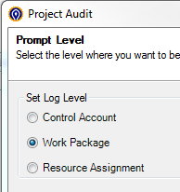

1. Enter only the Negotiated Cost on the Set Project Baseline screen. Click Next.

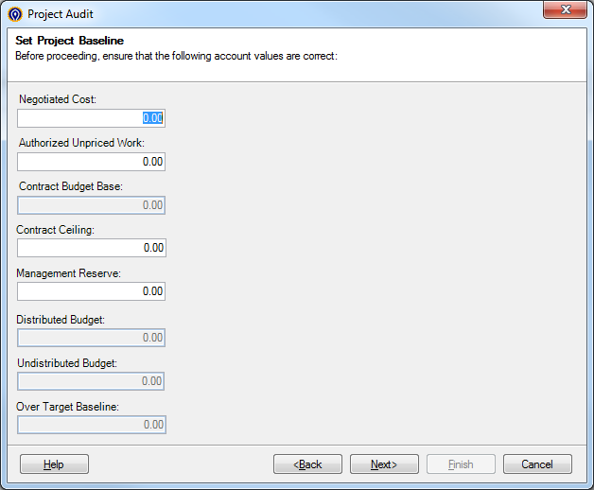

1. Enter, “Contract Award” as the Change Number and Change Comment. Click Finish.
2. Manually create a control account with no work packages. In Cobra open your project. Click the large green plus in the lower of the top banners to add a control account. Other options for adding a control account are to right-click while hovering your cursor in the blank WBS area or to click Edit>Add Control Account.

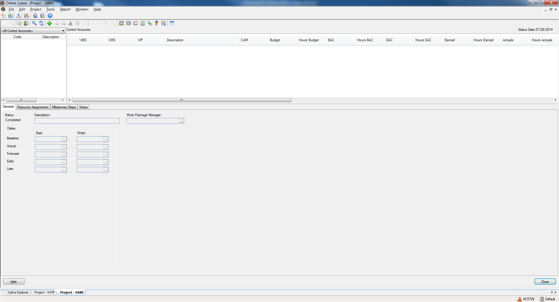

1. Click the ellipsis for WBS. Select the first WBS on the list. Click the ellipsis for OBS. Select the appropriate OBS for this control account. Don’t be concerned with the description, this will be filled in when the baseline is loaded. Enter a baseline start and finish date. This will be updated when the baseline is loaded. Don’t be concerned with CAM. Click OK.

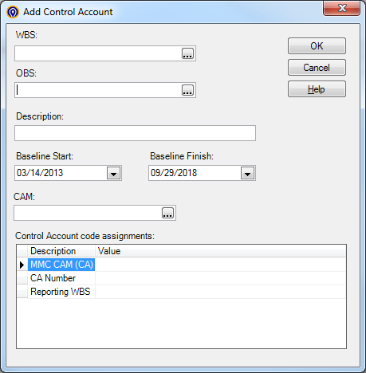

1. Advance the calendar. In Cobra click Project>Advance Calendar.
2. Turn the log off. In Cobra click Project>Project Audit. Select the radio button to Turn Log Off. Click Next.

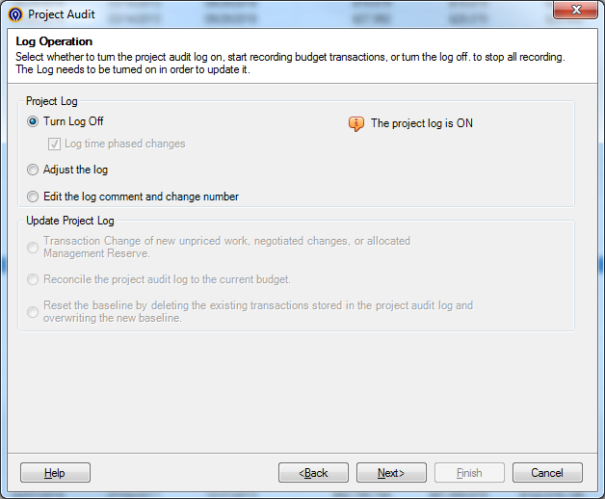

1. Enter, “Log Off” as the Change Number and “Log Off to load baseline” as the Change Comment. Click Finish.
2. Load and reconcile the baseline.
3. Turn the log on. In Cobra click Project>Project Audit. Select the radio button to Turn Log On and check the box to Log time phased changes. Click Next.

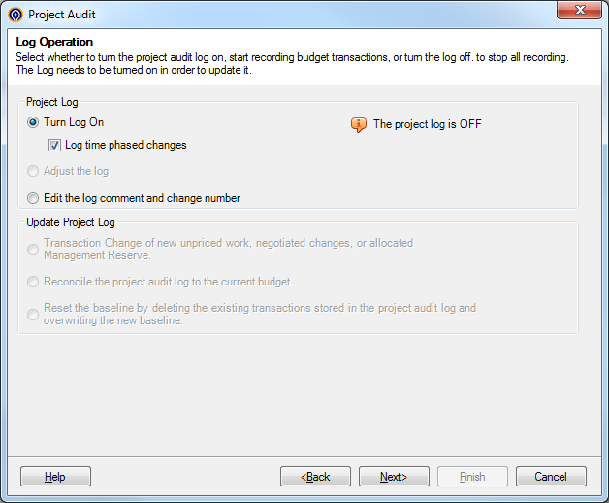

1. Enter, “Establish PMB” as the Change Number and “Establish PMB mmm yyyy” as the Change Comment. Click Finish.
2. Enter MR and any other transactions needed to bring the log up to current status.
3. Reclass Budget to ETC. In Cobra click Project>Reclass. Enter the project, click Next.
4. Check the box to Allow reclass of completed Control Accounts/Work Packages. Click Next.

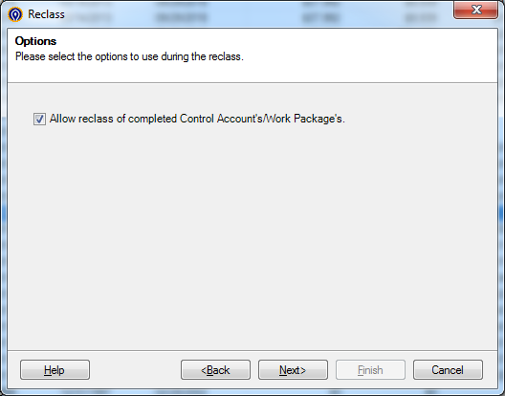

1. Enter Total Project as the Criteria. Click Next.

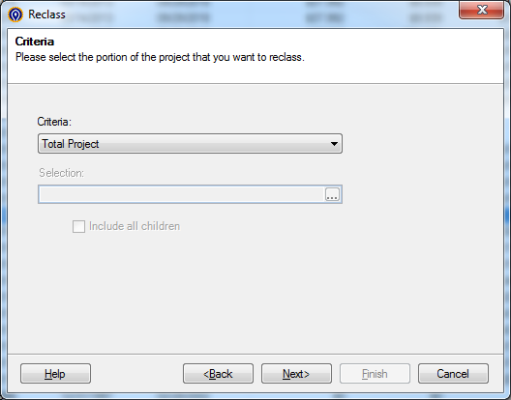

1. Click the ellipsis for source class, navigate to and select Budget. Select the radio button to Copy. Click Next.

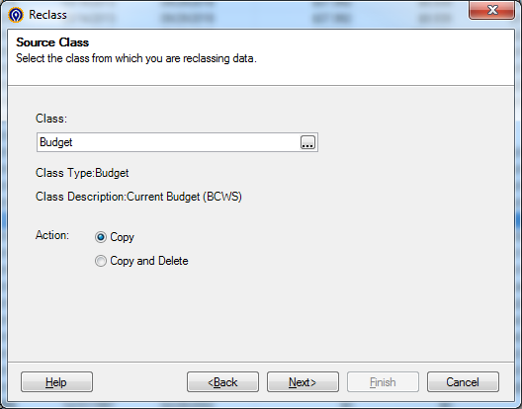

1. Click the ellipsis for Target class, navigate to and select Forecast. Select the radio button to Replace existing. Click Next.

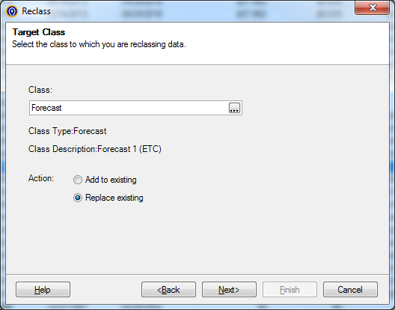

1. If you get a warning about the two classes using different rate sets, click OK.

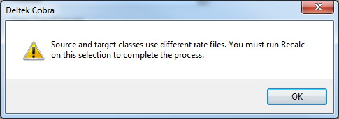

1. If your project uses the “Scale Retain EAC” option, you’ll get a warning asking if you want to include EAC values in calculating the total. Click Yes.

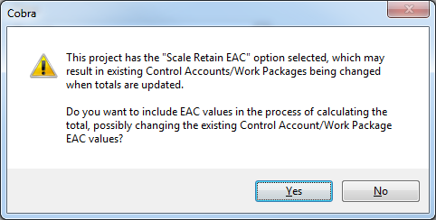

1. Select the radio button to Reclass all periods in your project. Check the box to Copy baseline dates to forecast dates. Click Next. Click Finish.

